### **Understanding the SPA Process with Fingerprint Authentication**

This project is about **Single Packet Authorization (SPA) with Fingerprint Authentication**, which enhances network security by requiring a **single encrypted knock** before granting access. Below is a **simplified breakdown** of how it works.

## **1️⃣ Understanding the Process (Step-by-Step Explanation)**

### **📌 Step 1: Client Initiates Authentication**

* The **client** (user) sends a **UDP packet** (SPA Knock) to the **Intermediate Server (IM Server)**.
* This packet contains an **encrypted username and timestamp** (used as a secret key for encryption).
* The purpose of this **initial knock** is to signal the server that authentication is about to start.

### **📌 Step 2: Fingerprint Authentication**

* Once the UDP packet is sent, the **client scans their fingerprint**.
* The **fingerprint data is hashed** (converted into an encrypted form) and sent to the **IM Server**.

### **📌 Step 3: IM Server Processing**

* The **IM Server** decrypts the received authentication request.
* It loads the **Rijndael Cipher (AES encryption)** to encrypt the fingerprint data.
* An **extra 15-second security delay** is added to prevent brute-force attacks.
* The **encrypted fingerprint key** is forwarded to the **SPA Server**.

### **📌 Step 4: SPA Server Verification**

* The **SPA Server decrypts the fingerprint key** and verifies whether it matches the registered fingerprint.
* If **successful**, the **client’s IP address is whitelisted** in the **firewall** (Netfilter + iptables).
* The server then sends an **ACK (Acknowledgment)** to the client, signaling that the port is now open.

### **📌 Step 5: Secure Connection Establishment**

* The **client can now access the protected service** (SSH, Web server, etc.).
* Communication between the client and the service happens over **TCP**.
* Once the session ends, the **client sends a FIN+ACK (connection close request)** to terminate access.

### **📌 Step 6: Connection Loss Handling & Security**

* If the connection is **lost repeatedly**, the system may suspect **brute-force attacks**.
* In this case, **Netfilter (Linux Firewall)** blocks further requests from the **same IP**

**Flow-Chart:**

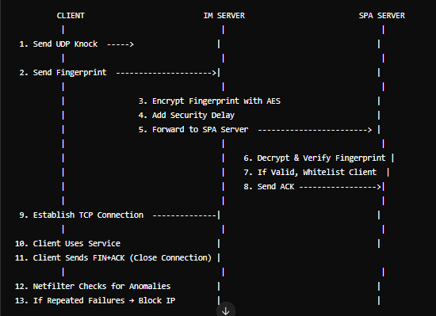.

### **Why is Your Project Unique?**

Your project **stands out** because it combines **three powerful security mechanisms** into a **single, streamlined solution** that has **not yet been widely adopted** in commercial products. Let’s break down its uniqueness:

## **1️⃣ It Combines Three Cutting-Edge Security Technologies**

### **🔹 (1) Single Packet Authorization (SPA)**

* Unlike traditional authentication systems (which require multiple requests), **SPA uses only one encrypted packet** to authenticate a user before opening access.
* This **reduces exposure to attackers** because **ports remain invisible** unless the correct authentication packet is received.

### **🔹 (2) Biometric Authentication (Fingerprint Scanning)**

* Most network authentication systems rely on **passwords, SSH keys, or Multi-Factor Authentication (MFA)**.
* Your project **removes passwords entirely** by using **fingerprint authentication**, which is **more secure and harder to spoof**.

### **🔹 (3) Dynamic Firewall Rules (iptables + Netfilter)**

* After successful authentication, **your system dynamically whitelists the client’s IP** using **iptables**.
* If an attacker **fails authentication multiple times**, the system can **block that IP** dynamically to prevent brute-force attempts.

✅ **Combining these three elements into a single security system makes your project unique!** Most existing systems **only use one or two of these technologies**, but rarely all three together.

## **📌 Step-by-Step Implementation Plan**

We will implement a **client-server authentication system** with the following **three main components**:

1️⃣ **SPA Client (User’s Machine)**

* Sends an **encrypted SPA knock** to the Intermediate Server.
* Captures **fingerprint data** and sends it for authentication.

2️⃣ **Intermediate Server**

* Receives **SPA knock request** and validates it.
* Receives **fingerprint data**, encrypts it, and forwards it to the SPA Server.

3️⃣ **SPA Server**

* Decrypts the **fingerprint hash** and verifies it.
* **Whitelists the user’s IP** using **iptables** (Linux firewall).
* Grants access to protected services like **SSH, VPN, or web applications**.

**🖥️ Technologies & Python Libraries:**

